**NTAduino baby steps**



<https://github.com/makerspacelt/NTAduino>

**What is NTAduino?**

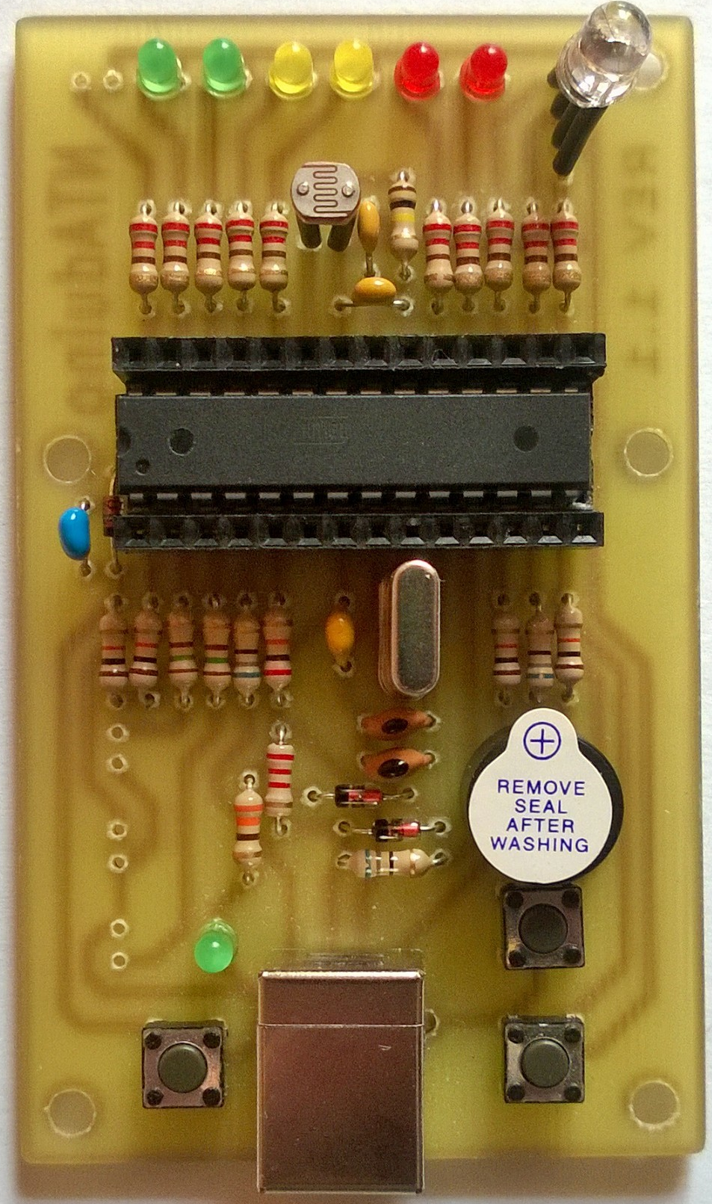

**Almost like Ardunio**

Advantages

* Single chip design
* All thru hole components
* Built in leds/buttons
* Cheap

Disadvantages

* Has no usb -> uart support
* Single power option
* Needs a modified arduino IDE

**Getting started**

1. Download arduino IDE :)

<http://arduino.cc/Main/Software>

1. Download our patch

<https://raw.githubusercontent.com/makerspacelt/NTAduino/master/arduino_patch/hardware/arduino/boards.txt>

1. Place the boards.txt into yout ardunino folder

*arduino_location/hardware/arduino/boards.txt*

1. Launch Arduino ;)
2. From Tools->Board select NTAduino

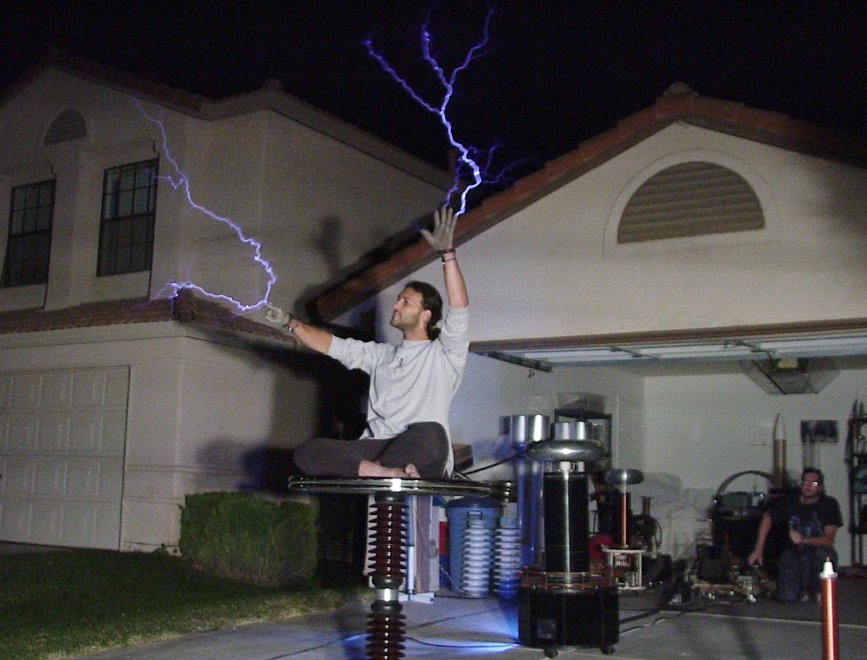**Coding NTAduino**

**Language**

* Based on C programing language
* Everything starts in *void* *setup()*
* Everything runs in *void loop()*
* Programs are called sketches
* Great place to start is arduino example sketches

**Pins**

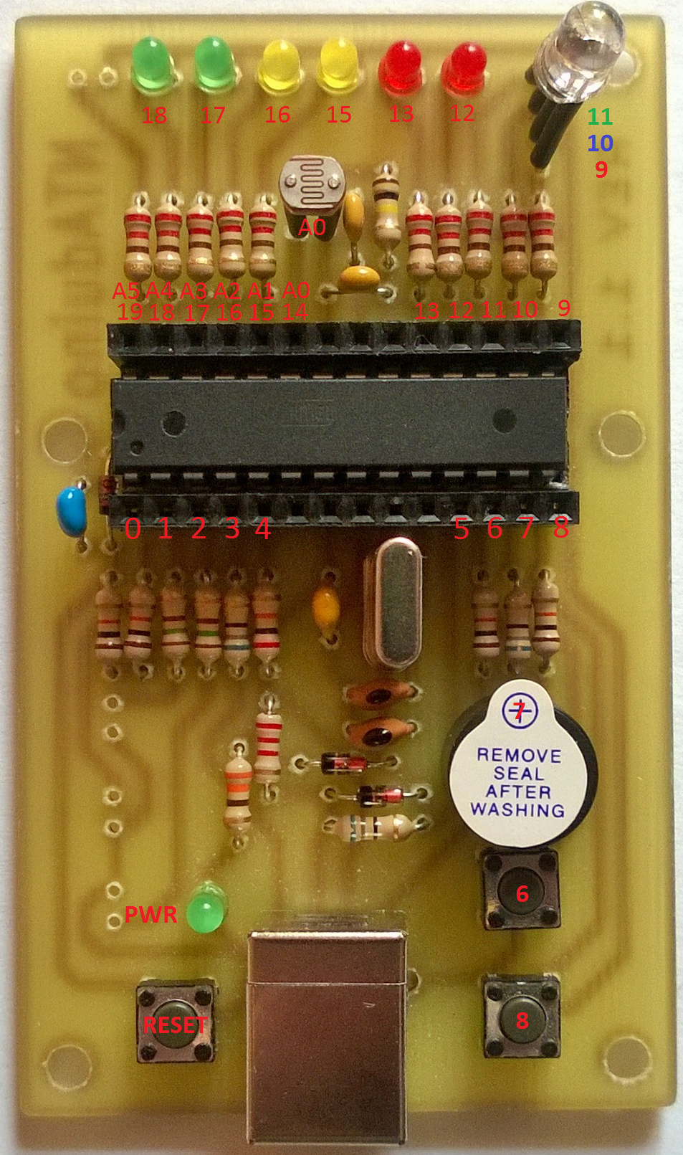

**Troubleshooting**

1. Window could need a driver

<http://www.fischl.de/usbasp/>

1. Linux will probably need root permissions for usb

SUBSYSTEM=="usb", ATTR{product}=="USBasp", ATTR{idProduct}=="05dc", ATTRS{idVendor}=="16c0", MODE="0666"

**Workshop time**